**Toy Model: User Manual**

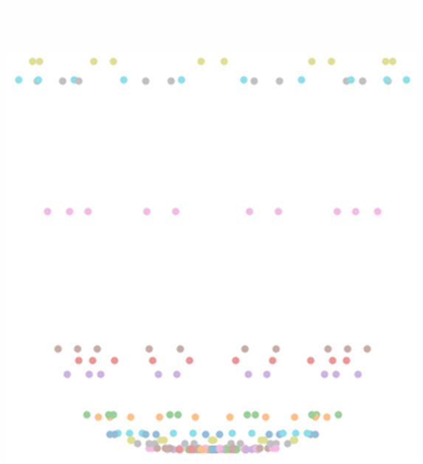Dominicus Ktori[1]*  
University of Hull

October 26th, 2022

Contents

Introduction 3

1 Toy Model Overview 4

1.1 What is the Toy Model? 4

1.2 Layout 4

1.2.1. Virtual Environment. 7

1.2.2. Units 7

2 Disk Setup (DS) 7

2.1 DS: Inputs and Outputs 8

2.2 DS: Inner workings 9

2.3 Mass Comparisons 11

2.4 Saving Data 12

2.5 DS: Considerations and Improvements 13

3 Particle Class (PC) 14

3.1 PC: Inputs and Outputs 15

3.2 PC: Inner workings 16

3.2.1. Potentials 16

3.2.2. Initial Velocity and Velocity Steps 17

3.2.3. Ram Pressure 18

3.2.4. Evolution 19

3.3 PC: Considerations and Improvements 20

4 Time Evolution (TE) 24

4.1 TE: Inputs and Outputs 24

4.2 Running the Simulation. 25

4.3 Saving Data 26

4.4 TE: Considerations and Improvements 27

5 Galaxy Infall (GI) 30

5.1 GI: Inputs and Outputs 30

5.2 GI: Inner workings 30

5.3 Finding Values 31

5.4 GI: Considerations and Improvements 31

6 Analysis 33

6.1 Stripping Radii 33

6.1.1. Analytic stripping radius 33

6.1.2. Toy Model Stripping Radii 36

6.2 Analysis Functions. 38

7 Main 39

7.1 Manipulating Data 39

7.2 Plotting 40

8 References 41

**Abbreviations/Referencing Key:**

* To make the code clear to the reader, code in this document is written with the font Consolas.
* Many Figures are screenshots of code split into sections denoted with a #. For these sections, after the figure has been first referenced, it is then abbreviated show with the following example: Figure 5 #3 becomes 5#3.
* Pressing ctrl and click on blue underlined text will take one to the Figure it references.
* Abbreviations: TM - toy model, RP - ram pressure, ICM - intracluster medium, DM - dark matter.

# Introduction

This user manual explains the workings of a particle toy model (TM) used to simulate RP stripping. Originally, the python code was created as part of my Master’s Project titled: ‘Ram Pressure stripping of Extreme Jellyfish Galaxies.’

In its current version the code is suitable for the initial RP stages: the ‘RP pushing’ phase. Throughout the manual I have add potential improvements to the TM.

I hope the code is of use and looking forward how others develop the TM.

*Acknowledgements: The TM would not have been possible without the support and help of my Supervisor Dr E. Roediger, Dr C. Cashmore and the astrophysics team Dr.*

*Thank you.*

# Toy Model Overview

## What is the Toy Model?

A simple model where equidistant particles are setup in the x-y plane. Accelerations from potentials (the DM halo, Stellar Disk and Bulge) centered at the origin and initial circular velocities evolve the galaxies orbits in time increments, , 1x1013s. An acceleration due to RP is applied in positive z direction to each particle. The RP each particle experiences depends on its assigned surface density. The RP is derived from the Gunn & Gott (1972) prescription, and the Drag Force Equation, Eq (6) (Hoerner, 1965). The RP is altered, i.e., calibrated to hydrodynamic simulations, by varying the drag coefficient, $c_{W}$.

## Layout

The TM is found in the file Final_Control_Centre which contents are shown in Figure 1.

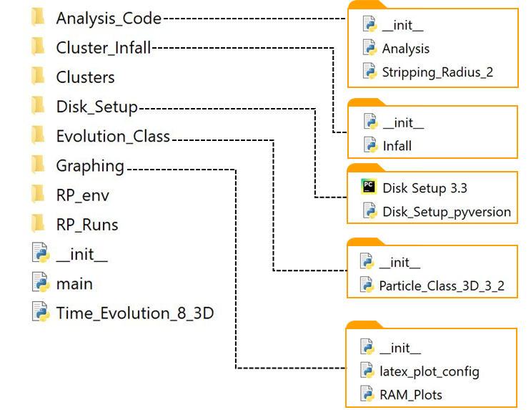

Figure 1: Diagram of directories in Final_Control_Centre.

A brief overview of each file and directory will be explained in the following:

* main - This file serves as a center where the data from different areas of the TM can be analyzed and plotted.
* Time_Evolution_8_3D - Where the RP simulations are conducted and parameters determined. The runs are performed by calling the class Particle from Particle_Class_3D_3_2.
* Evolution_Class - The file contains Particle_Class_3D_3_2 which is responsible for evolving the particle gas disk.
* Disk_Setup - The file Disk Setup 3.3 (or Disk_Setup_pyversion) is responsible for setting up a particle gas disk. Each particle assigned properties such as mass and surface density.
* Cluster_Infall - Inside the directory Infall, a galaxy is basically modelled as it travels radially into a cluster. The velocity and position are recorded for use in time-varying RP runs.
* Anaysis_Code - The analytic stripping radius for the gas disk is determined in Stripping_Radius_2. Functions used to extract simulation data, such as find the gas mass within tails, are found in Analysis.
* Graphing - RAM_Plots which provides quick plotting functions such as plotting the disks radial stability. latex_plot_config contains a simple function to determine the matplotlib figure sizes used in LaTeX publications.
* Clusters and RP_Runs contain the pickled data for simulations of RP stripping and cluster infall respectively.
* RP_env is the virtual environment for the TM library.

Figure 2 outlines where data is imported/exported and which files are dependent on functions/class from other directories.

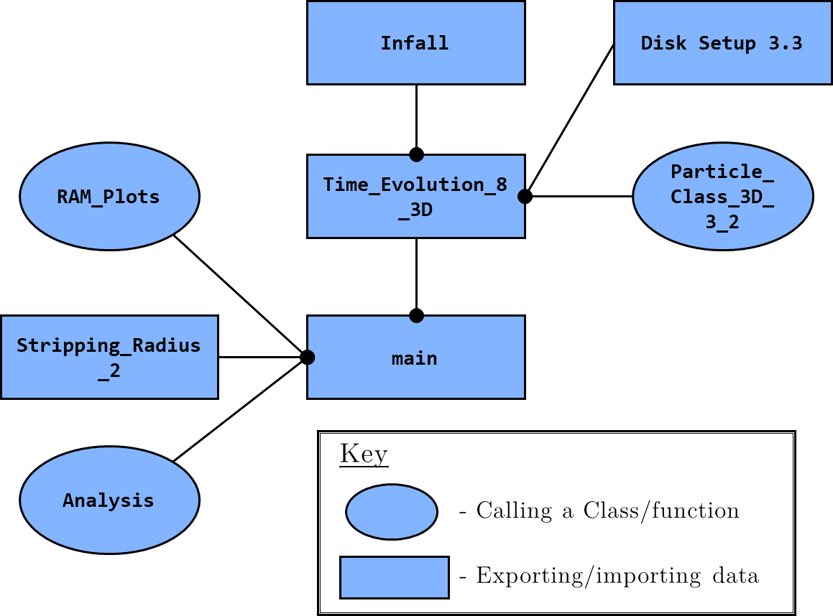

Figure 2: A diagram showing how each file in TM interlinks. The circular text box represents functions that are called into a file. The square text boxes represent files where data is created and imported/exported to.

1. A galaxy is created in the x-y plane in Disk Setup 3.3. It consists of a gas disk of particles and assigned properties i.e., mass. The particle data is saved to text files in Disk_Setup.
2. Time_Evolution_8_3D imports the text file and runs the data through the class Particle, called from Particle_Class_3D_3_2. The class evolves the particles and applies a RP.
3. For time varying RP the infalling galaxy’s velocity and position are required. These components are calculated in Infall and saved as pickle files in Clusters.
4. Time_Evolution_8_3D opens the cluster pickle files and inputs the data into Particle.
5. Upon completing a RP simulation that data is pickled in Time_Evolution_8_3D and exported to RP_Runs.
6. The file main is where the RP Simulation data is opened and analyzed with functions called from Analysis. The analytic stripping radius is calculated in Stripping_Radius_2 with data saved as a pickle file in Analysis_Code. These Stripping radii are opened in main to compare to RP simulation data. Quick plots can be made in main by calling functions from RAMS_Plots.
   * 1. Virtual Environment.

In this manual RP_env represents the virtual environment. For users a new virtual environment will need to be created. I have replaced the contents of RP_env with a list of libraries used.

* + 1. Units

All inputs are in units of kg, km, and s. It is hard to visual, particularly distances, in these units so I have added conversion constants such as pc2km. Therefore, one can write 2.3*pc2km instead of $7.1×{10}^{13}$. The only exception is the file Stripping_Radius_2 which uses units of solar masses and parsecs, see section 6.1.

# Disk Setup (DS)

The first stage of the TM is setting up the galaxy’s gas disk either in Disk Setup 3.3 (ipynb file) or Disk_Setup_pyversion (py file), both contain the same code.

**Overview:** A line of equidistant particles are created along the x axis; each a ‘gas cloud’ at a given radius. This line represents a segment that is duplicated, at an angle, $θ$, to create a gas disk in the x-y plane, see Figure 3. Each particle is assigned an area, surface density and mass. The particles’ data is then saved as a text file in Disk_Setup.

**Tips**: I suggest running the code in Jupyter Notebook (the ipynb file Disk Setup 3.3) or a text editor where the code can be divided into cells. This segmentation is useful to test the properties of a galaxy at each stage of the setup.

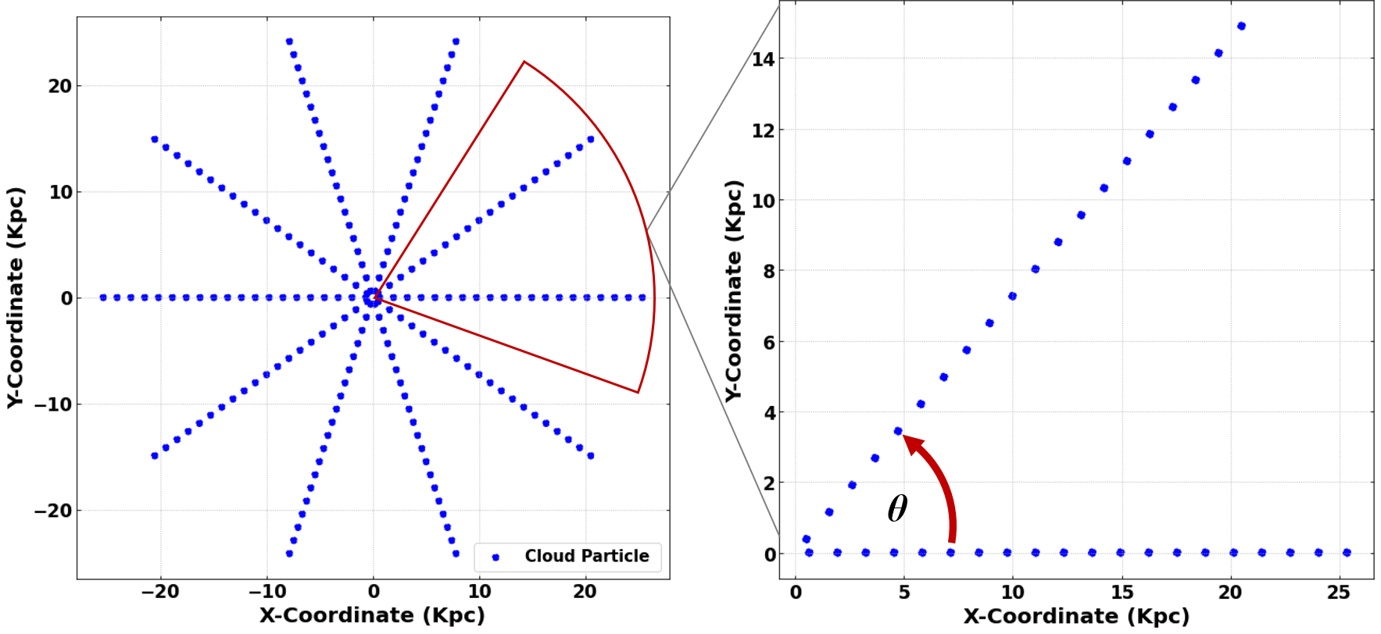

Figure 3: The left-hand diagram shows a gas disk created in Disk Setup 3.3. The right-hand side shows 2 segments enlarged and the angle, $θ$, between the them.

## DS: Inputs and Outputs

Disk Setup 3.3 requires and produces the following:

Inputs:

* Radius of disk - maxr
* Number of particles per segment - npart_in_seg
* Number of segments - nseg
* Total gas mass - Mgas_tot
* Scaling radius for 2D soften exponential - a

Outputs

* Radius of each particle - rpart_actual2
* x, y, z coordinate of each particle - xpart, ypart, zpart
* Angle of the segment: assigned to every particle - theta
* Mass of each particle - mass
* The area assigned to each particle - p_area_elm
* Surface density of each particle - surf_rho_at_r
* The mass enclosed at each radius increment - m_enc

## DS: Inner workings

In Disk Setup 3.3, a line of equidistant particles is created to the maximum radius, maxr, see Figure 5. Though it may seem intuitive to set the particles at evenly spaced intervals from 0 to maxr. The particles are instead set at an offset as shown in the example, Figure 4, below.

**Max Radius = 6000 pc**

**Number of Particles = 3**

**Original Radius**

$$∆r$$

3000 pc

0 pc

6000 pc

$${∆r}/2$$

**Shifted Radius**

Each cloud Shifted by

1500 pc

7500 pc

4500 pc

Figure 4: A diagram illustrating how a line of particles (representing gas clouds) is created in the Disk Setup 3.3. Where the circles represent the particles and ∆r the distance between them.

5#1 is a for loop where the variable dummy_r setups up the ‘original radius’ for each particle along with the x, y components, xpart and ypart.

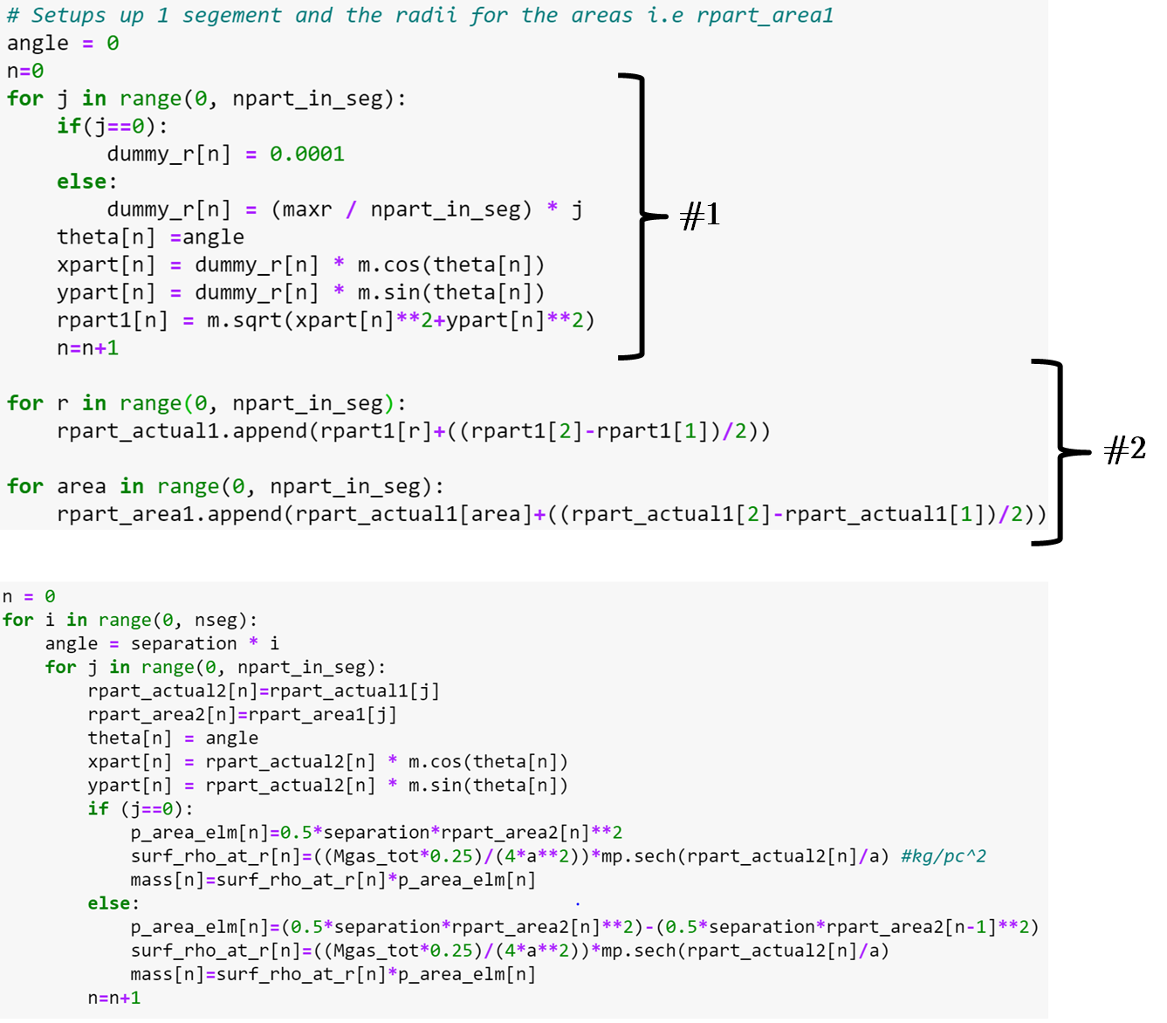

*A part of Figure 5 continued onto the next page.*



**#3**

**#4**

Figure 5: Sections of code from Disk Setup 3.3 divided into parts annotated by a # with a number to signify the order.

The ‘shifted radius’ is created in 5#2 by rpart_actual1 and replicated in 5#3 for all the segments via angle = separation*i. In 5#4 an area, surface density and mass are assigned to the particle. For the area Eq. (1) is used,

|  |  |  |
| --- | --- | --- |
|  | $$A=\frac{1}{2}θ{\left(Δr\right)}^{2}$$ |  |

where $θ$ is the separation angle between the segments and $Δr$, the radial difference between each particle.

1500 pc

4500 pc

6000 pc

3000 pc

0 pc

$$∆r$$

$${∆r}/2$$

Gas Particle (rpart_actual2)

rpart_area2

**θ**

Figure 6: A diagram showing a segment of the gas disk with an angle, $θ$. The orange circles represent gas particles written as an array rpart_actual2. The diamonds represent the border radii of the areas, defined in th code as rpart_area2.

From 5#2 rpart_area1, a further shifted line of rpart_actual1, is replicated for all segments in 5#4 and called rpart_area2, illustrated in Figure 6. The areas radii, black diamonds, are ${∆r}/2$ greater than the gas particles, orange circles. Hence, rpart_area2 is the shifted array of rpart_actual2.

|  |  |  |
| --- | --- | --- |
|  |  |  |

|  |  |  |
| --- | --- | --- |
|  |  |  |

Eq. (2) is a 2D soften exponential derived from the 3D version, Eq. (3). Where $M_{g}$ is the gas mass, $a_{g}$ the scaling radius and $r$, the radius. To note, $M_{g}$ is not the final gas mass of the galaxy but the value before integration and labeled as Mgas_tot, see section 2.1 (Roediger & Brüggen, 2006).

The mass for each particle is determined simply by $Σ\left(r\right)A$. Hence, why the gas particles (rpart_actual2) ‘sit’ in the middle of the assigned area (rpart_area2), shown in Figure 6. If the boundary of the area is position at rpart_actual2, there would be a non-negligible error between $Σ\left(r\right)A$ and the integrated cumulative mass, Eq (4). Therefore, a gas disk’s mass profile is more accurately described with a greater number of particles per segments rather than more segments and fewer particles.

## Mass Comparisons

In order to see if the disk’s cumulative mass approximation is accurate, it is compared to Eq. (4). The numerically integrated mass, found using Eq (2).

|  |  |  |
| --- | --- | --- |
|  | $$\int_{0}^{r_{max}}{\frac{πM_{g}r}{2a^{2}}{0.5}^{2}sech\left(\frac{r}{a_{g}}\right)dr}$$ |  |

First the analytic enclosed mass is calculated. In Figure 7 #1, the function Integrate is called into the list mass_intgd0. Then integrate.quad computes the definite integral between 0 and the maximum radius, $r_{max}$. The result are 2 values stored at each index in mass_intgd0: the value of integration and the associated numerical error. In 7#2, a for loop ‘selects’ the enclosed mass value which is appended to mass_intgd. This list’s cumulative value will be the actual total gas mass of the disk unlike Mgas_tot.

Second, the particles mass array, mass, is called in 7#3. The array contains a particle’s mass at each radius in a segment and repeated for all segments. To illustrate, consider the example below where there are 2 segments, 3 particles in each.

*Segment:* ***1******2***

*Radius: r1 r2 r3 r1 r2 r3*

The segments are repeated, where each particle, at a given radius, has the same mass. In 7#3 Counter(mass), counts the particles with the same mass and then the for loop multiplies the mass by the ‘count’. The result, after applying np.cumsum(), is m_enc, the cumulative mass of all the particles at a given radius, from the inner most to outer most radii. Therefore, the length of m_enc is dictated by the number of particles in one segment, see continuation of example below.

*Radius: r1 r2 r3*

The last line in 7#3, print(m_enc[-1]/(MO2kg*1E10)), is useful as it shows the galaxy’s total gas in 1010. The value of Mgas_tot is a higher estimation than the disk’s actual mass total, m_enc[-1]. 7#4, a test plot, compares the analytic mass enclosed to the actual disk mass enclosed.

## Saving Data

The data is saved to a text file in columns as shown in 7#5. Where data1 contains information on every particle’s: x-y-z coordinates, angle, radius, surface density, mass, and area. As such, if there are 10 segments each with 10 particles, a ‘column’ in data1 will have 100 values. The radii for particles in 1 segment and the total mass enclosed at each radius is contained in data2. Continuing the example, a ‘column’ will have 10 values.

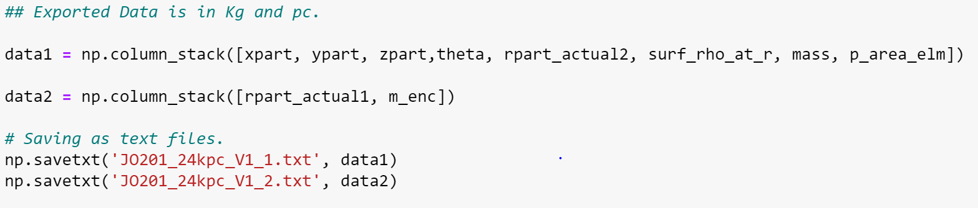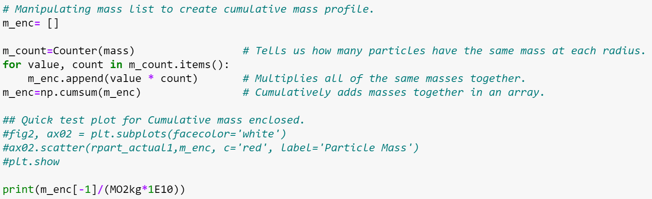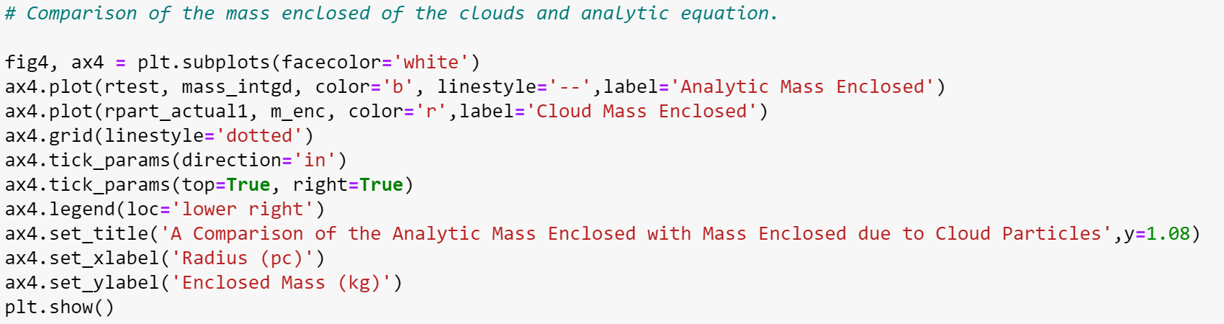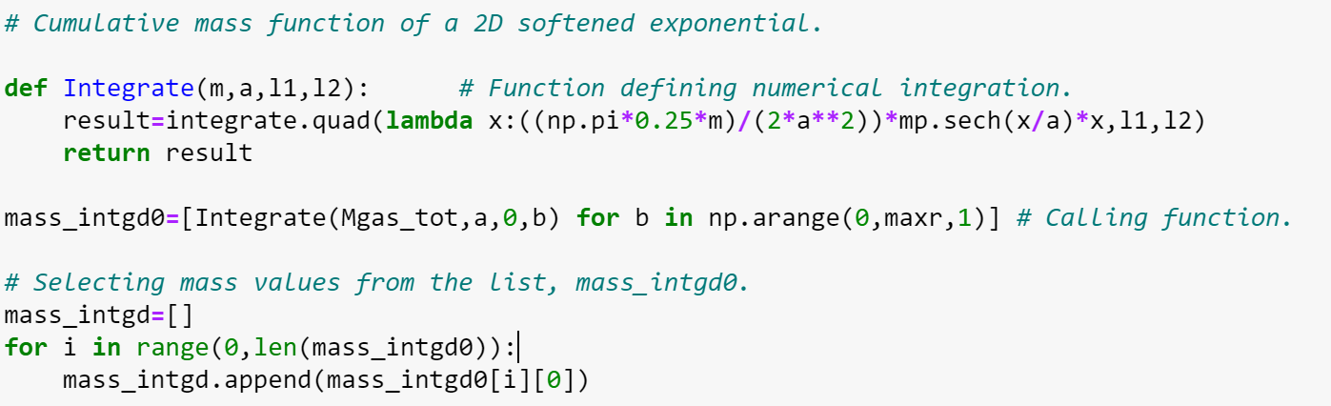

**#1**

**#2**

**#3**

**#4**

**#5**

Figure 7: Sections of code taken from Disk Setup 3.3. #1-3 show how the analytic cumulative mass of the galaxy is calculated. #4, a plot comparing the galaxies enclosed mass at a given radius to that calculated analytically. #5, shows a key snippet on how parameters of Disk Setup 3.3 are saved.

## DS: Considerations and Improvements

An obvious improvement would be to add a directory function for saving the text files. I did not deem it necessary to create such a function as in practice only a few galaxy disks are need. However, in the case where one is testing a variety of parameters for a galaxy, a directory function maybe needed. Time_Evolution_8_3D and Infall, sections 4 & 5, contain a directory function that can be emulated.

Another addition to the code would be a function/variable that determines the surface density type. Therefore, one could choose between having a softened exponential or say an exponential such as in Boselli & Gavazzi 2006. To implement a 3D surface density, like Eq (3), is more complicated as it violates the G&G assumptions which the TM is based on.

In the ipynb file, Disk Setup 3.3, the code is split into cells making it convenient to run. For the py version, Disk_Setup_pyversion, the code could be split into functions and sections only called when necessary.

An alternative method for the disk setup is to move particles to given radius given the surface density profile. Originally, this approach was tried, however it was found shifting to the desired radii required interpolation which increased run times. Moreover, it then becomes unclear what area and mass to assign to each particle.

# Particle Class (PC)

The class Particle evolves galaxy (gas disk) and applies a RP. The class is called in Time_Evolution_8_3D, see section 4.

**Overview:** The class allows 6 arguments containing information about a particle’s: x, y, z coordinates, angle, surface density and mass. Theses parameters are taken from the text file created in Disk_Setup. The accelerations due to the gravitational components of the galaxy are calculated and the particles are given an initial circular velocity. The particles then orbit in the x-y plane with time increments, $dt$, $1×10^{13}$ s. A RP is applied in z-direction over a chosen time period and can be either constant or time-varying.

**Tips:** Ensure all the desired properties are in the array history and list ramhistory. Add more properties then required as they can be useful checks in case of an unexpected outcome.

The index I_develop can serve most time varying RP runs. Though there are scenarios where, I_infall is useful, such as suddenly exposing a galaxy to an ICM after an initial infall into a cluster: a ‘shielded’ infall.

## PC: Inputs and Outputs

Inputs:

The main 4 arguments are:

* x,y,z coordinates - x,y,z
* Particle’s angle (dependent on its segment) - theta
* Particle’s surface density- surf_rho
* Particle’s mass - mass

Outputs

There are 3 main outputs of the class. First, an array called history, it contains the desired information for every particle at each time step i.e., the velocity, z position, etc. Second, a list, ramhistory, contains RP information for every particle at each time step. The last output, partly created in Time_Evolution_8_3D, contains the same information as history but stored as a 3D array, see Figure 8. The 3D array is useful when wanting to quickly isolate large chunks of data. For example, taking a ‘slice’ of the array containing all particle radii over all time. Whilst history, in some circumstances, can be easier to implement into functions. Details on how to use the outputs can be found in sec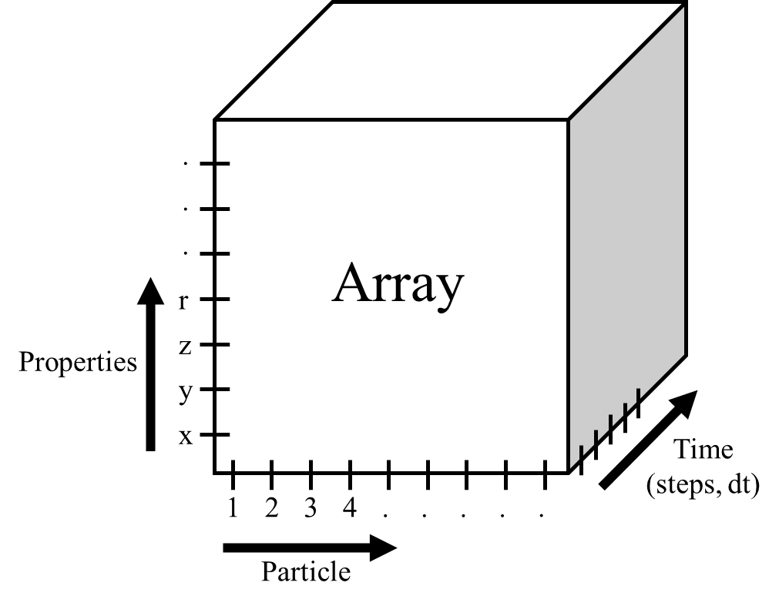tion 7.

Figure 8: A representation of the 3D array as cube. Each axes refers to the indexes for the galaxies: properties, particles and time.

## PC: Inner workings

Lines of code are referenced from the file Particle_Class_3D_3_2 with key sections highlighted in Figures 10 & 11.

In lines 15-54 the variables/constants are required in the class file because they are imported and changed in Time_Evolution_8_3D. From 58 - 76, the __init__ function initializes the attributes of the class e.g., ramhistory, line 74.

* + 1. Potentials

The accelerations due to the gravitational potentials are defined in lines 84-122. Where Darkmatter_Contribtuion(self), Bulge_Contribution(self), Stellar_Disk(self) are functions for the DM halo, Bulge and Stellar Disk components respectively. As of version 3.2, the bulge is defined by a Hernquist potential and the stellar disk by a Miyamoto-Nagai (Miyamoto & Nagai, 1975, Hernquist, 1990). The DM halo can be defined by a Mori-Burkert or a Hernquist potential (Mori & Burkert, 2000). All potentials are centered at the origin in cartesian coordinates. Many simulations use a Navarro–Frenk–White (NFW) model for the DM halo (Navarro et al., 1996). Though, in the TM, this potential cannot be resolved analytically for x-y components. The Hernquist potential offers a good approximation to NFW. The variable DMtype can toggle between the models with inputs ‘Hernquist’ or ‘Mori’. The spherical potentials’ (Hernquist & Mori-Burkert) 3D radial accelerations are calculated by $\frac{dθ}{dR}$, (in code called Rcontrib). The 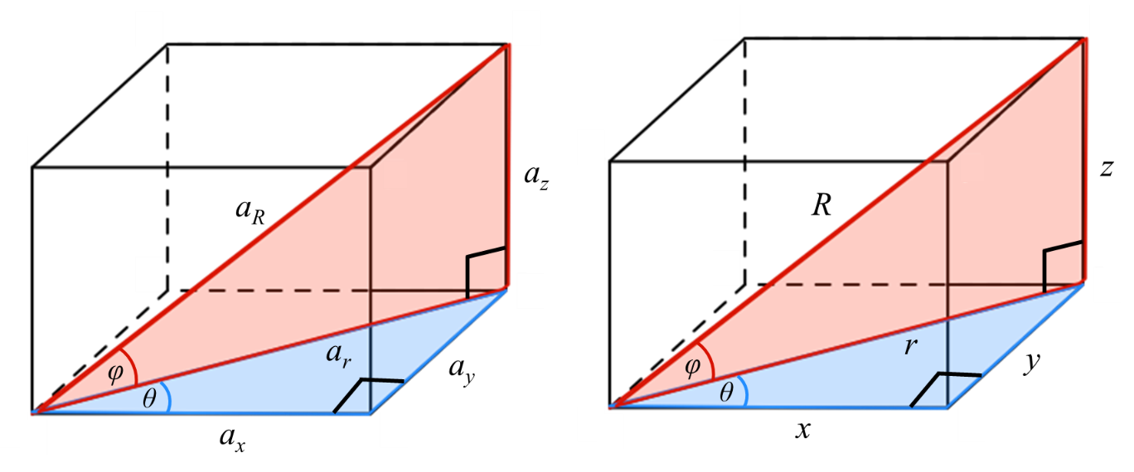 x, y, z and 2d radial contributions are calculated by simple trigonometry, see Figure 9. The left diagram represents the components of the acceleration and the right, the coordinate components. R, r, x, y and z denote components of the 3D radius, 2D (x-y plane) radius, and x, y, z axes. The example below, shows how the components of the accelerations were resolved for $a_{r}$ and $a_{x}$.

Figure 9: The left diagram shows the components of the gravitational acceleration due to the potentials. The right-hand side shows the components of the displacement.

$$cos\left(φ\right)=\frac{a_{r}}{a_{R}} , cos\left(φ\right)=\frac{r}{R}$$

$$\frac{a_{r}}{a_{R}}=\frac{r}{R}$$

$$a_{r}=a_{R}\frac{r}{R}$$

$$cos\left(θ\right)=\frac{a_{x}}{a_{r}} , cos\left(θ\right)=\frac{x}{r}$$

$$\frac{a_{x}}{a_{r}}=\frac{x}{r}$$

$$a_{x}=a_{r}\frac{x}{r}$$

Sub in $a_{r}=a_{R}\frac{r}{R}$,

$$a_{x}=a_{R}\frac{x}{R}$$

The stellar disk, lines 113-122, is an asymmetrical potential in cylindrical coordinates, as such the acceleration in the z plane was found by $\frac{dθ}{dz}$.

The function Total_Acc(self) totals the respective acceleration components for the DM halo, Bulge and Stellar disk.

* + 1. Initial Velocity and Velocity Steps

For the particles to orbit (with respect to the origin) they require initial velocities setup by Initial_Velocity(self), see Figure 10. The circular velocities of the DM halo and Bulge, lines 148-158, are found by substituting their enclosed mass equations $M(r)$ into the circular velocity equation $v_{c}=\sqrt{\frac{GM}{r}}$. Notice, $M(r)$ is different depending on the potential used for the DM halo: Mori Burkert or Hernquist. The stellar disk’s $v_{c}$ was computed by equating the centripetal acceleration $a_{r}=\frac{v_{c}^{2}}{r}$ with the radial force, in the galactic plane $(z=0)$, see calculation below.

$$\frac{v_{c}^{2}(r)}{r}=-F_{r}(r,z=0)={\left.\frac{∂Φ(r,z)}{∂r}\right|}_{z=0}$$

$$v_{c}(r)=\sqrt{{\left.r\frac{∂Φ(r,z)}{∂r}\right|}_{z=0}}$$

The circular velocities of each component are combined in lines 164, 165. Then the x-y components of the initial velocities (at t=0) are resolved in lines 168, 169.

The function Velocity_Step(self, dt) provides the equations that evolve the initial velocities with an acceleration at a time step, $dt$, as shown in lines 176-178 (for $dt$ details see section 3.2.4). A particle’s velocity, at each $dt$, depends upon the velocity at the previous time step. Similarly, the x, y, z coordinates are updated in lines 180-182 from the calculated velocities and .

* + 1. Ram Pressure

In Figure 10, line 178, the z velocity depends on an extra variable zram_vel: a velocity due to RP. This parameter is calculated in Ram_Pressure(self, t_rp, v_w, rho_w, r_cl, dt, wind), line 210, Figure 11. The function’s arguments are as follows:

* t_rp is the RP duration.
* v_w is the ICM wind velocity.
* rho_w is the density of the ICM.
* r_cl is the radial position in the cluster.
* dt is the time step.
* wind is the type of RP.

The type of RP, determined by wind_type, can be ‘constant’, ‘varying’ or ‘test’. For the constant case the input r_cl can be ignored as the ICM density and wind do not vary. pram_orig represents the original RP as defined by G&G, Eq. (5),

|  |  |  |
| --- | --- | --- |
|  | $$p_{ram}=ρ_{ICM}{v_{ICM}}^{2}$$ |  |

where $ρ_{ICM}$ is the ICM density and $v_{ICM}$ is the ICM wind velocity in the galaxies rest frame. The RP takes the form of Eq. (7), denoted by pram_max, line 217, which is derived from the drag force, Eq. (6), and Eq. (5).

|  |  |  |
| --- | --- | --- |
|  |  |  |

|  |  |  |
| --- | --- | --- |
|  |  |  |

|  |  |  |
| --- | --- | --- |
|  |  |  |

is the drag force, $c_{w}$ is the drag coefficient and $A$ is the area. $v_{rel}$ is the relative velocity between the ICM wind and the galaxy (Hoerner, 1965). The RP acceleration, zram_vel, is given by Eq. (8), line 217. The if statement, 219-222, sets $v_{rel}$ limit to 0 which prevents negative values.

Time-varying RP tuns consider the galaxy infalling into the cluster, as such both the ICM density and wind will change. The cluster’s density is determined by a beta profile Eq. (9): $ρ_{0}$ is the spectral density, $r_{c}$ the core radius and $β$ the slope parameter (Schindler et al 1999). In the code is denoted by rho_vw, line 227.

|  |  |  |
| --- | --- | --- |
|  | $$ρ_{ICM}=ρ_{0}{\left(1+\frac{r^{2}}{r_{c}^{2}}\right)}^{-\frac{3}{2}β}$$ |  |

The radial distance from the cluster centre, $r$, and the galaxy’s velocity as it infalls are given as list rcluster and v_vwind calculated from the file Infall, see section 5. These lists are called in Ram_pressure() with the arguments v_w and r_cl, see line 204.

* + 1. Evolution

In Cvel(self, t, dt, ram) all the functions are called (directly or indirectly) to evolve the particles. The argument t, is the total number of time steps, $dt$. A time increment of 1 x 1013 s (3.15 Myr) was chosen as it provided details of the RP stripping without hindering computational performance. A larger , 1 x 1014 s, led to unstable inner orbits and inaccuracies in the particles’ z velocities. A Smaller $dt$, i.e., 1 x 1012 s increased run times, in some cases, by 354 % without a significant improvement to the orbital stability (used a Microsoft Surface Pro 4, 4 Gb RAM).

The array history is created in lines 189-191 which records the desired parameters. In Particle, history is a 2d array with axes t and n - the number of particle parameters. Notice, history_shape(t,14) n=14, so 14 parameters. An extra dimension is added to history in Time_Evolution_8_3D making it a 3D array, see section 4. The for loop, line 193, is where the evolution takes place. Line 194, Velocity_Step() is called allowing the particles to orbit in the x-y plane.

Second, the RP is applied for a time duration which is achieved by inputting a 2 integer list into Cvel() via the argument ram. The inequality condition, line 196, defines the RP period with the start being the first index of list, ram[0]. The end of the RP is defined by the second value of the list, ram[1]. The values of the list ram are in terms of $t×dt$.

In the varying case, I_develop=int((I-ram[0])/dt)), line 198, iterates over the lists’ v_vwind and rcluster for the arguments v_w and r_cl respectively. To explain the indexing let us say Cvel(self, t, dt, ram) has the following arguments t=10, dt=1 x 1013 s, and ram=[5*dt, 8*dt]. The galaxy will evolve in the x-y plane and at 5 $dt$ the RP will be initiated until 8 dt: a total duration of 3 dt. The scenario where the galaxy evolves before falling into the cluster requires indexes 0 to 3, in the lists’ v_vwind and rcluster. However, from ram, we have 5 $dt$ to 8 $dt$. Therefore, the start value (first index), ram[0], is subtracted from I (where I is in terms of $t×dt$) then divide by *dt* to give the range 0 - 3. Hence, I_develop=int((I-ram[0])/dt).

In the scenario when the galaxy has already fallen into the cluster before being exposed to a wind, such as in a ‘shielded’ infall the variable I_Infall=int(I/dt) is employed. If the galaxy has fallen a distance, $d$ into the cluster. Then we want the indexes in rcluster and v_vwind that correspond to galaxy’s velocity and ICM density at $d$. Thus, simply $I/dt$.

To note: the Ram_pressure() parameter t_rp is iterated over by I-ram[0]. Strictly speaking, t_rp is only needed to ensure the correct RP duration for the wind type, ‘test’. It had a more prominent role in earlier versions of the code when the RP was based on a Lorentzian profile from Vollmer et al 2001.

During the for loop, lines 208-209 update each of the particle’s parameters in history. Similarly, ramhistory is updated for each time step when Ram_pressure() is called in lines 201-206.

## PC: Considerations and Improvements

An immediate improvement would be to decrease the time increment, $dt$, to 1 x 1012 s if reasonable run times could be achieved on one’s computer. Potentially, the accuracy of the tail velocities could be increased because the RP velocity would be better described at each time step.

The time increment should be kept the same across the entire TM library. The argument dt was kept in Ram_Pressure() for future testing and edits to the code but could just be removed as it is superfluous in the current TM.

Two major ‘upgrades’ the class needs are galaxy inclination and a method that extends beyond the RP pushing phase. Inclination can be implemented either by angling the galaxy to the ICM wind or by changing the direction of the RP stripping. The latter, on the surface seems the simpler option. A rotation matrix could be implemented into the RP’s acceleration components and Cvel(). The former method involves rotating the galaxy’s potentials adding complexity. A major limitation of the TM is it cannot describe the full multistage process known as RP stripping. The intermediate and continuous stages could better be described by a more sophisticated RP setup (Roediger & Brüggen, 2006). A method I have dabbled with is changing the velocity at different heights above the disk. Though, this technique is effective in simulating intermediate stripping, it is arbitrary. Many hydrodynamic stripping profiles could be emulated as there are no constraints on the velocity manipulation.

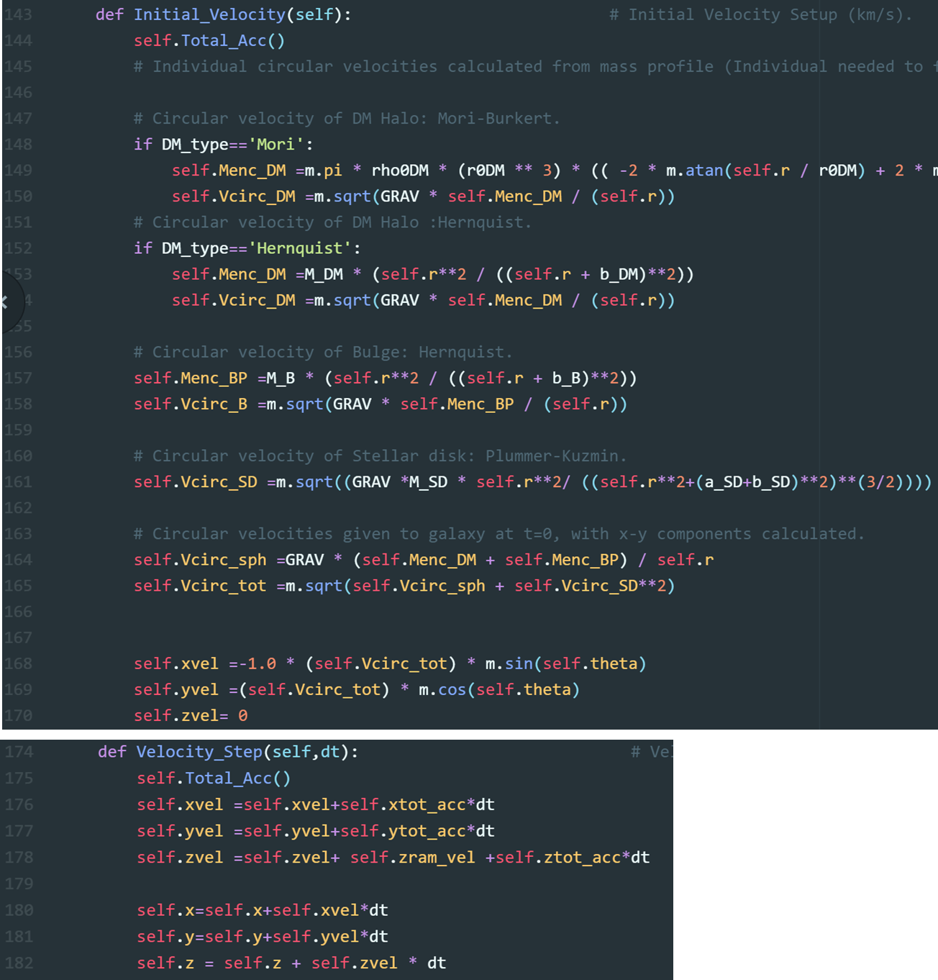

Figure 10: Key sections of code from Particle_Class_3D_3_2. The first panel refers to setting up the initial velocities. The second panel, shows how the velocities evolve with accelerations from the potentials and RP.

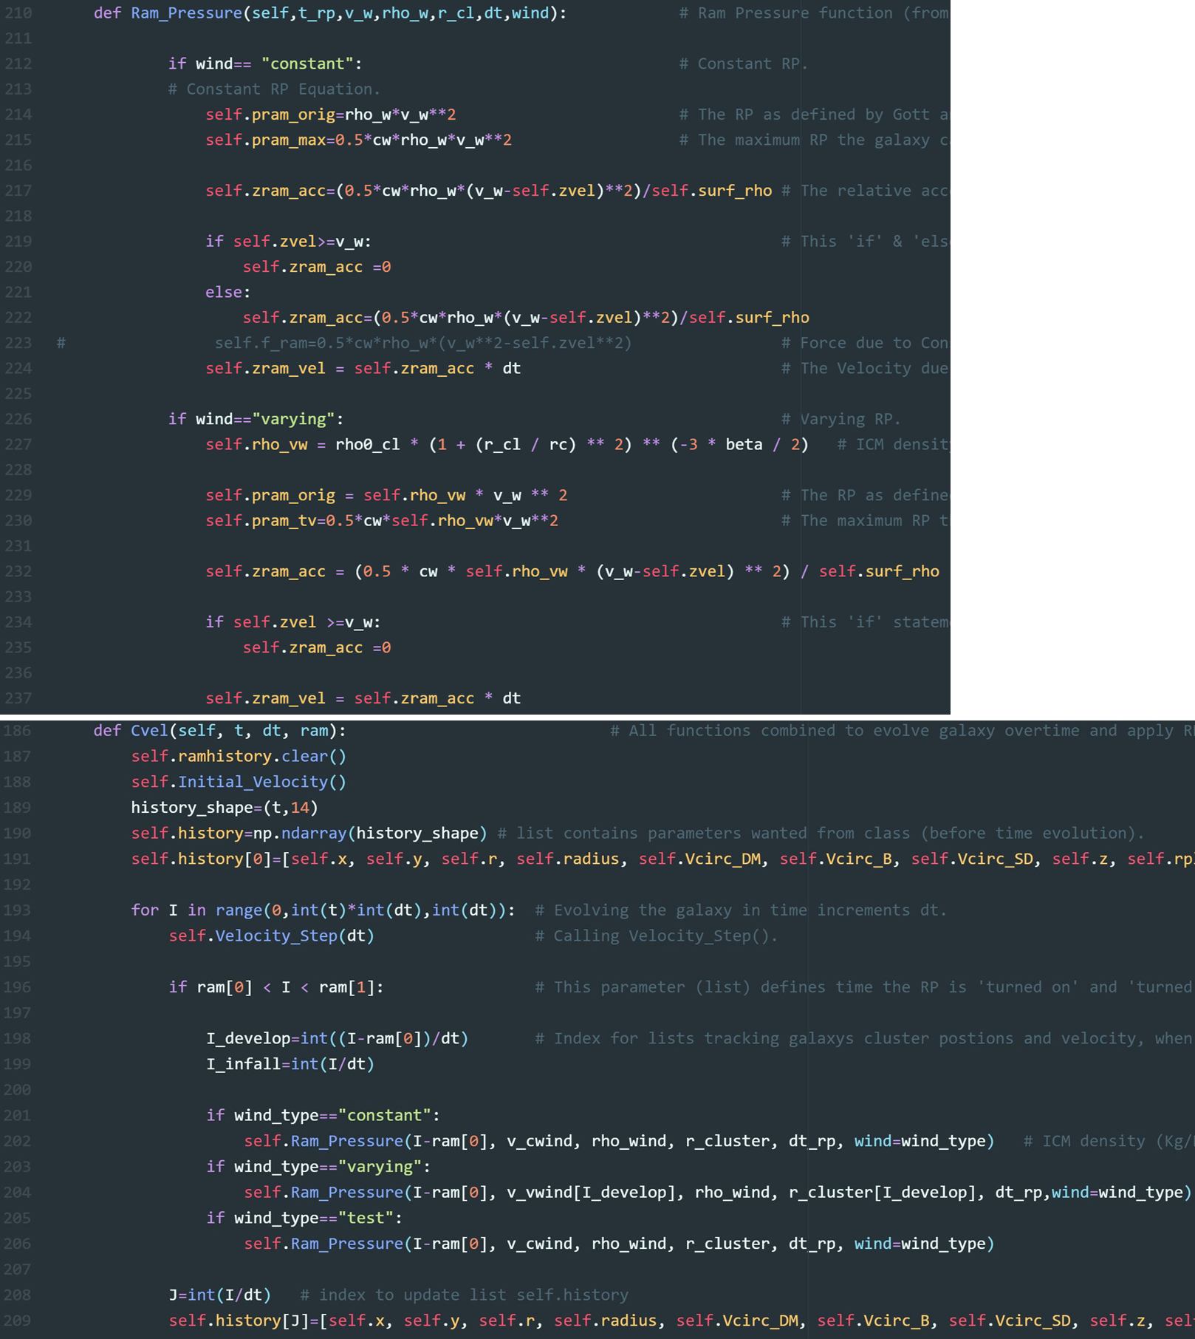

Figure 11: These are sections of code from Particle_Class_3D_3_2. The first panel shows how the RP is calculated. The second panel, how the galaxy is evolved over time and the RP applied.

# Time Evolution (TE)

**Overview:** The file Time_Evolution_8_3D is where the TM simulations takes place. Information on the gas disk and cluster infall are imported from Disk_Setup and Clusters respectively. Once parameters are determined, such as the stellar disk mass, the class Particle is called in the list RAMs. This class iterates through each individual particle over time, at a time step, $dt$. Upon completion, RAMs consists of class objects, each index containing all the information of a particle at every time step. The information is also presented as 3D array called data. RAMs and data are saved as pickle files to a desired directory via the function Saving_data_to_file().

## TE: Inputs and Outputs

For Time_Evolution_8_3D there are various inputs required mainly to define the potentials. Apart from these constants, I will highlight the key parameters required for a run, in order of appearance from Figure 14.

Main Inputs

* In lines 21-35 the text files from Disk Setup 3.3 are loaded. The particle parameters from each column in the file are defined as lists. The required parameters for the arguments of Particle are: xpart, ypart, thetapart, surf_rho_at_r, mass.
* Lines 38 - 41 loads the pickle file created in Infall. The 2 lists needed, from the file, for time varying RP are the galaxy’s velocity and the corresponding radial cluster position. These lists are held by the variables v_vwind and r_cluster (lines 73, 74) respectively. Notice, wind_velocity is multiplied by -1. In Infall the galaxy travels towards the origin along the z axis with a negative velocity. However, the class Particle defines the ICM wind along the positive z axis. Hence, the imported velocities into Time_Evolution_8_3D are multiplied by -1.
* The potential for the DM Halo can be chosen on line 44 by inputting ‘Mori’, Mori-Burkert, or ‘Hernquist’, Hernquist model.
* On lines 66 npart is the total number of gas disk particles decided in Disk Setup 3.3. This variable determines the number of iterations Particle is called.
* The RP conditions are defined in lines 70-83. The type of RP is chosen by inputting either ‘constant’, ‘varying’ or ‘test’ into wind_type, line 82. For details see section 3.
* The time conditions, in lines 87-90 are determined by t, the total run time, in units of dt, the time step, set to 1x1013s. The time the RP starts is rp_i and stops, rp_f.

## Running the Simulation.

A galaxy run is performed by 3 lines, 95-97, Figure 14. Inside a for loop Particle is called in the list RAMs and is iterated over by total number of gas disks particles, npart. Each argument in Particle is given a list (from a Disk_Setup text file) of the particle parameters such as coordinates, mass etc. A list’s index signifies the parameter for one particle. If xpart[i] contains the x coordinates for 200 particles, at the zeroth index (xpart[0]) is the x coordinate for the first particle. The second particle, index 1 (xpart[1]) and so on.

In the for loop, line 97, a particle is iterated over for the total simulation time, t, before moving onto the next particle; illustrated with Figure 12. Moreover, the argument rams specifies the start and finish of the RP for Cvel. Where RAMs[-1] ensures that the RP time conditions (rp_i, rp_f) are also applied to the last index/particle in the list before progression onto the next. After the iteration through t, the particle’s ‘evolution’ is stored as class object in the list RAMs. Thus, for the first particle, at index 0, its class object will be stored at RAMs[0]. The next particle, at index 1, will then be evolved through t and stored at RAMs[1], etc. A progression bar was implemented with the package tqdm which tracks the time taken for all the particles to be iterated through.

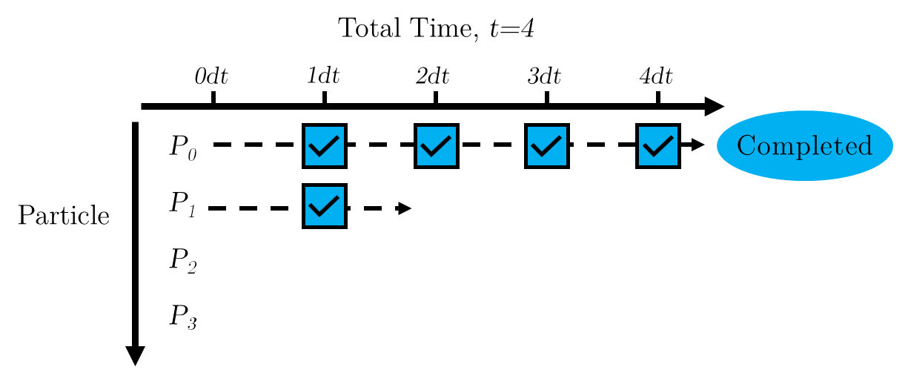

Figure 12: A diagram showing how the particles are evolved in the class Particle. A particle P0, P1, etc is iterated through the total number of time steps before progression onto the next.

## Saving Data

The 3D array, data (created with line 92, 93 & 99) and RAMs are saved to a directory via the Saving_data_to_file() function, line 103-128. The arguments are as follows:

* The parent directory - parent_directory
* The directory where the data is saved - galaxy
* Saving RAMs - file_name_1
* Saving data - file_name_2
* Parameters used to in the simulations to create RAMs/data - parameter_list

To explain, let us reference Figure 13 where a simulation of D100 is saved with a 0.9 $c_{w}$ value. The run is saved to the parent directory, RP_Runs. Hence, the first argument is parent_directory= ‘RP_Runs’. Usually, a run belongs to a certain galaxy, thus the second argument galaxy is ‘D100’. In the 3rd/4th argument RAMs and data are named as file_name_1= ‘RAMs_cw0_9’ and file_name_2= ‘Data_cw0_9. A List of parameters for the run is saved to the D100 directory as a text file where parameter_list = ‘Parameters’. The name of the run in Parameters is identified by file_name_1. Another D100 run is conduct for a 1.2 cw value and file_name_1 called ‘RAMs_cw1_2’. Parameters will be subsequently updated with the conditions of the second simulation. To note: Parameters will contain all variables including ones not used in the simulation. For example, in Figure 13, RAMs_cw0_9 is a time varying run but the constant wind velocity, Wind Vel: 1500 (km/s) is still recorded.

The behavior of Saving_data_to_file() is governed by lines 108 -124, see Figure 15. First the data is saved to a path designated in line 108. Where os.path.join() concatenates the path components with a one directory separation. The statements, lines 109 - 115, specify that if the path exists save files to the end directory. If the path does not exist then it is created with os.makedirs(path), line 113, and the file saved. Second, the text is written. Lines 117,118 command that if the directory to Parameters does not exist open and write text. When the file already exists, alter text, line 123, and write a second set of parameters for a subsequent run.

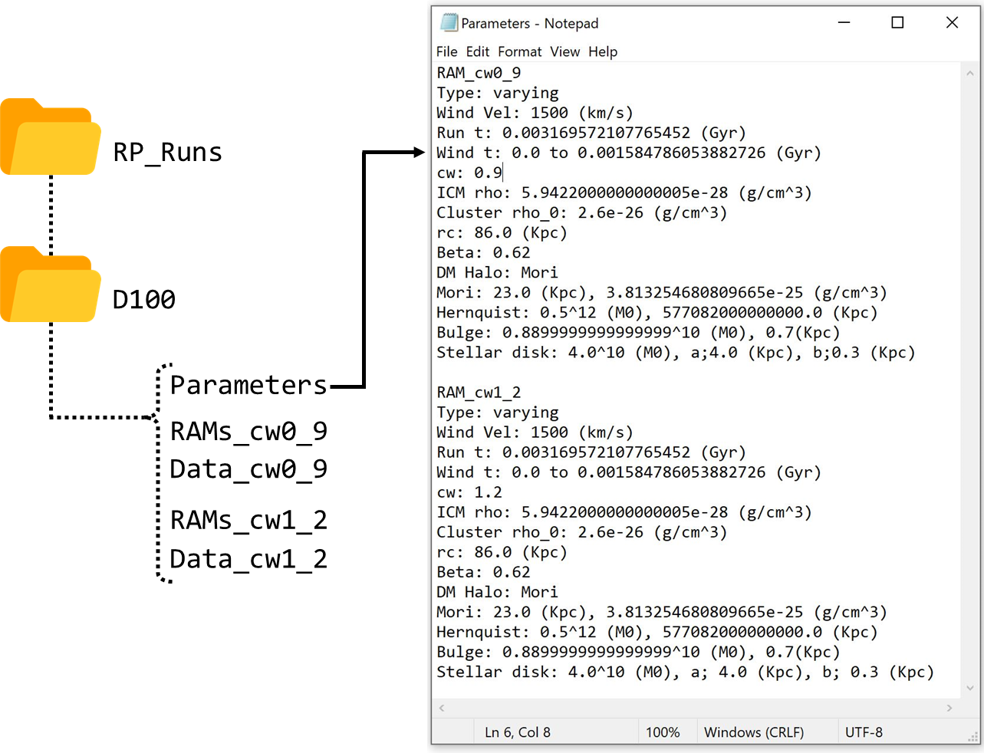

Figure 13: A diagram showing a directory path where example D100 data files are saved. The Parameters Notepad document (right side) illustrates how the properties of the run are displayed.

## TE: Considerations and Improvements

Though the purpose of Time_Evolution_8_3D is to simply perform runs and save data there are potential improvements. One could create a 3D array for the list ramhistory like data. Originally, data was designed to quickly access large chunks of particle information. In practice, ramhistory contained only 1 or 2 variables at any given time. Therefore, implementation of a 3D ramhistory array was not necessary. The addition of a GUI is welcomed, though cosmetic, it would make inputting parameters clearer.

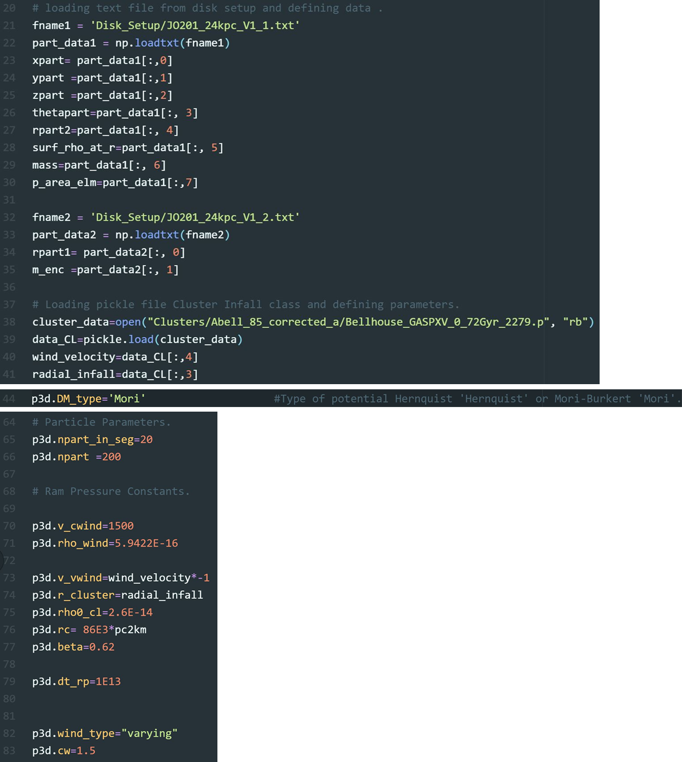

Figure 14: The top panel highlights, in Time_Evolution_8_3D, the required imported data to run a simulation. The middle panel, the variable that controls the DM halo model type and the bottom panel, the parameters needed for RP stripping.

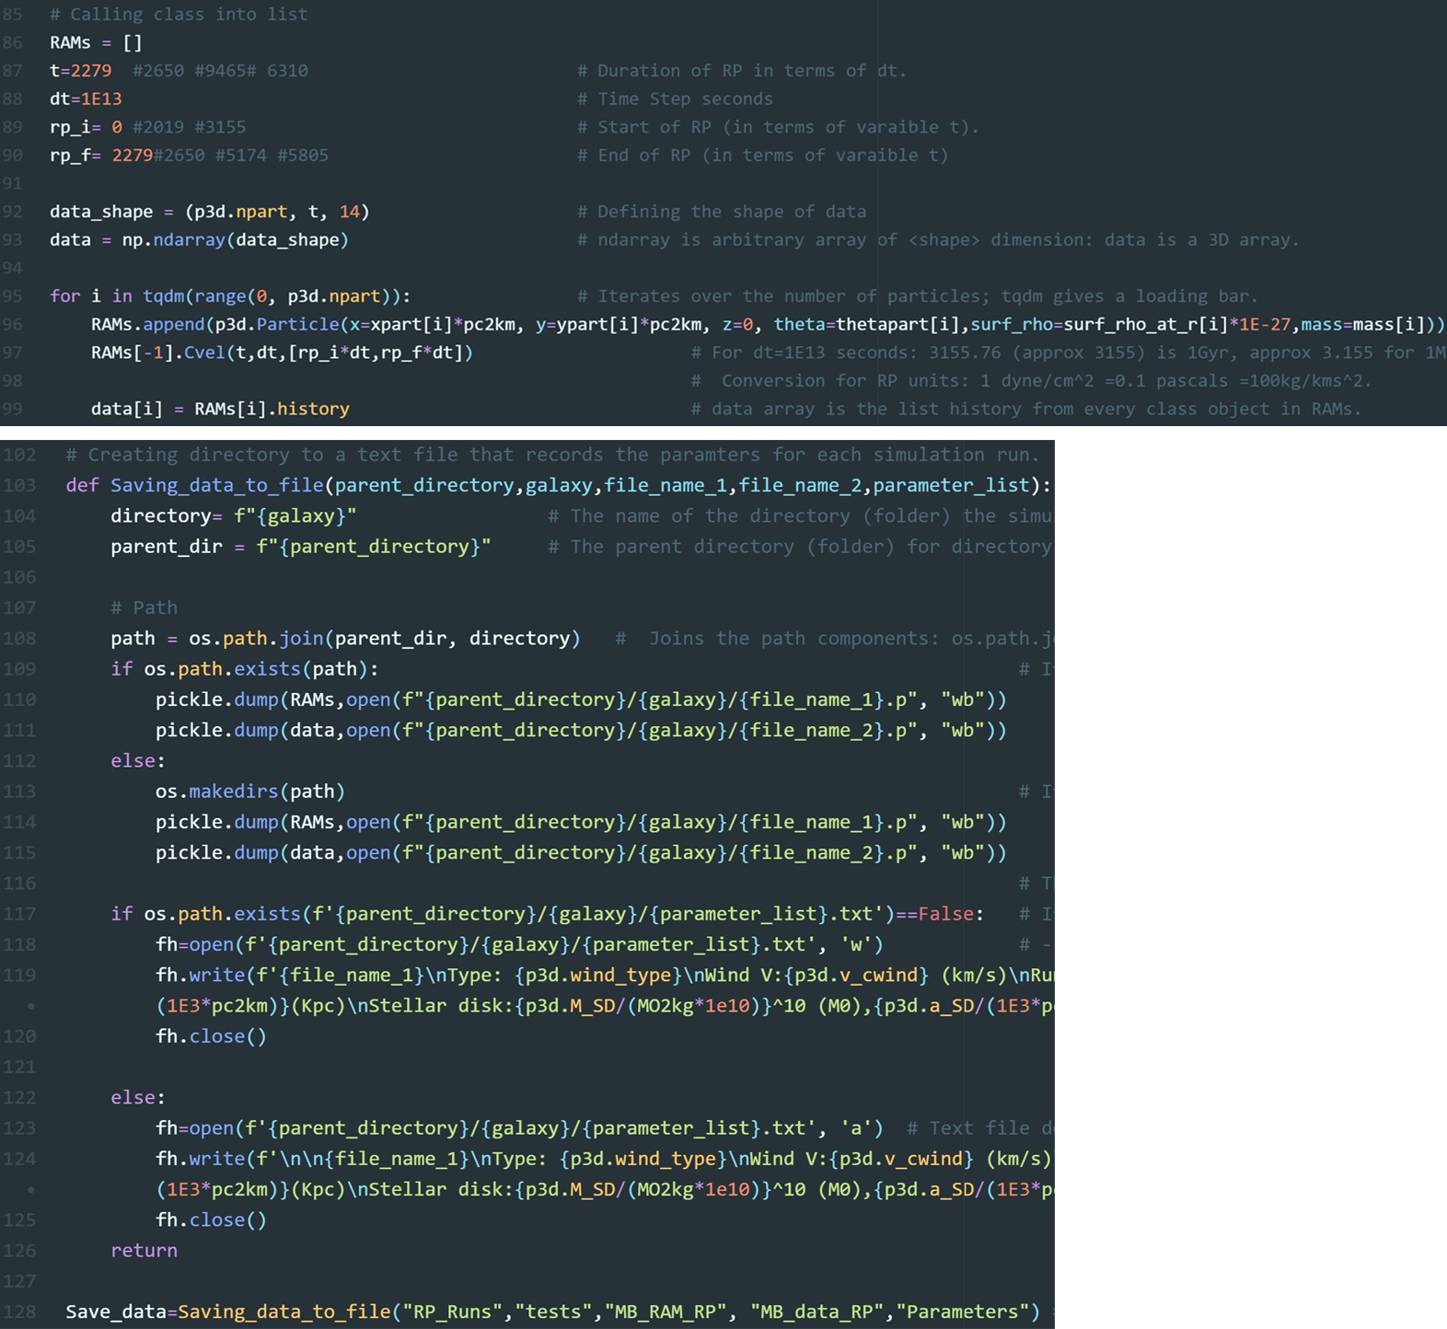

Figure 15: The upper panel shows a for loop where the class Particle is called. This for loop is where a ‘simulation’ is run in Time_Evolution_8_3D. The Lower panel shows a function that saves the RP stripping run to a directory path.

# Galaxy Infall (GI)

**Overview:** A particle representing a galaxy is accelerated radially along the z axis by a Hernquist potential centered at the origin. A representation of a galaxy infalling towards the cluster center. The velocity and position are recorded/stored in the array data_cl which is then saved to a directory via the function Saving_cl_data_to_file().

**Tips:** Once, the simulation/run is completed, instead of immediately saving the data, one can analyze the aspects of RP stripping dependent on the infall. Code at bottom of the file provides plots for ICM beta and RP profile. These plots can be used to determine if the initial conditions are appropriate.

## GI: Inputs and Outputs

The main inputs and outputs are as follows:

Inputs:

* x,y,z coordinates - x,y,z
* Galaxy’s initial velocity - Infall_v0
* Time - t
* Cluster mass - m_CL
* Scaling radius - b_CL

Outputs:

A list, data_cl, containing the z components of the velocity and position.

## GI: Inner workings

The class Cluster_Infall is a simplified version of Particle, see section 3. In Figure 17, lines 23-28, a particle is positioned on the positive z-axis and given an initial negative z velocity i.e., simulating the galaxies radial infall. The cluster potential represented by a Hernquist sphere, centered at the origin, accelerates the particle in the negative z direction. Much like Particle, a 2D array, history_CL, is created to record the desired variables during the infall time, t, see lines 118-120. The row of the array represents time values and the column’s the particle/galaxy parameters. The class is called in the list INFALL, line 131, and history_CL is appended to data_Cl, line 134.

To save data a directory function, Saving_cl_data_to_file(), similar to that of Time_Evolution_8_3D, is employed, see section 4. The 2 minor differences are first only one set of data is pickled. Second, as illustrated with Figure 16, the function navigates to the previous directory Final_Control_Centre, through to Clusters and then to the 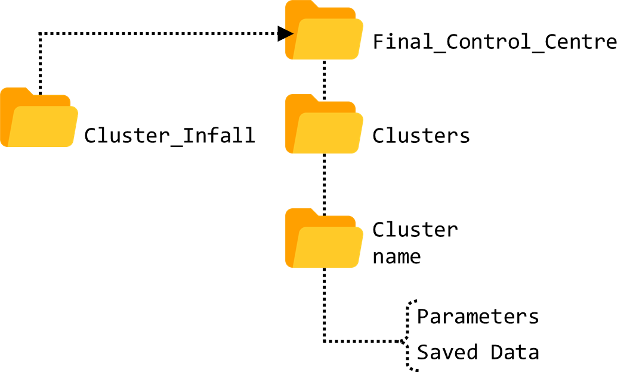specific Cluster name where the data is saved.

Figure 16: A diagram showing an example directory path used by the function Saving_cl_data_to_file(), to save data from Infall.

## Finding Values

To help find the desired final cluster centric coordinates and velocity, lines 168 - 200, Figure 17, serve as a check. Though detailed comments have been provided in the py file an overview will be discussed here.

Varying the initial velocity and Hernquist potential can dramatically affect the final velocities and positions. Thus, in order to quickly select sensible parameter for the simulated infall; we compare to the known values of the galaxy’s projected cluster centric distance and velocity. For example, JO201 has a projected radial distance from the cluster center of 360 kpc with a suspected velocity of >3363 km/s (ref paper). Theses properties are represented by z_value (z coordinate) and v_value (z velocity). The function closest_value()is called to find the closest z_value and v_value from the simulation lists gal_z (z position)and gal_v (z velocity). These desired values are labelled val_z and val_v. The corresponding indexes are the variables index_z and index_v. For Figure 17, the velocity, val_z , corresponding to the cluster position, gal_z, was printed in line 198.

## GI: Considerations and Improvements

A major improvement for Infall would be to program more realistic orbital paths. This upgrade could be taken in steps. For example, one could include the x, y components of the acceleration due to the gravitational potential to begin before implementing more complicated orbital mechanics.

Figure 17: Sections of code from the file Infall. The first panel shows key variables need to run the code. The second and third panels present parts of the class Cluster_Infall. The final panel, shows how desired velocities and cluster centric distances are found.

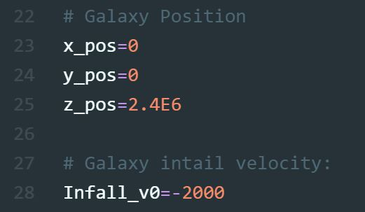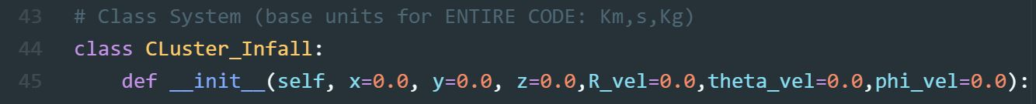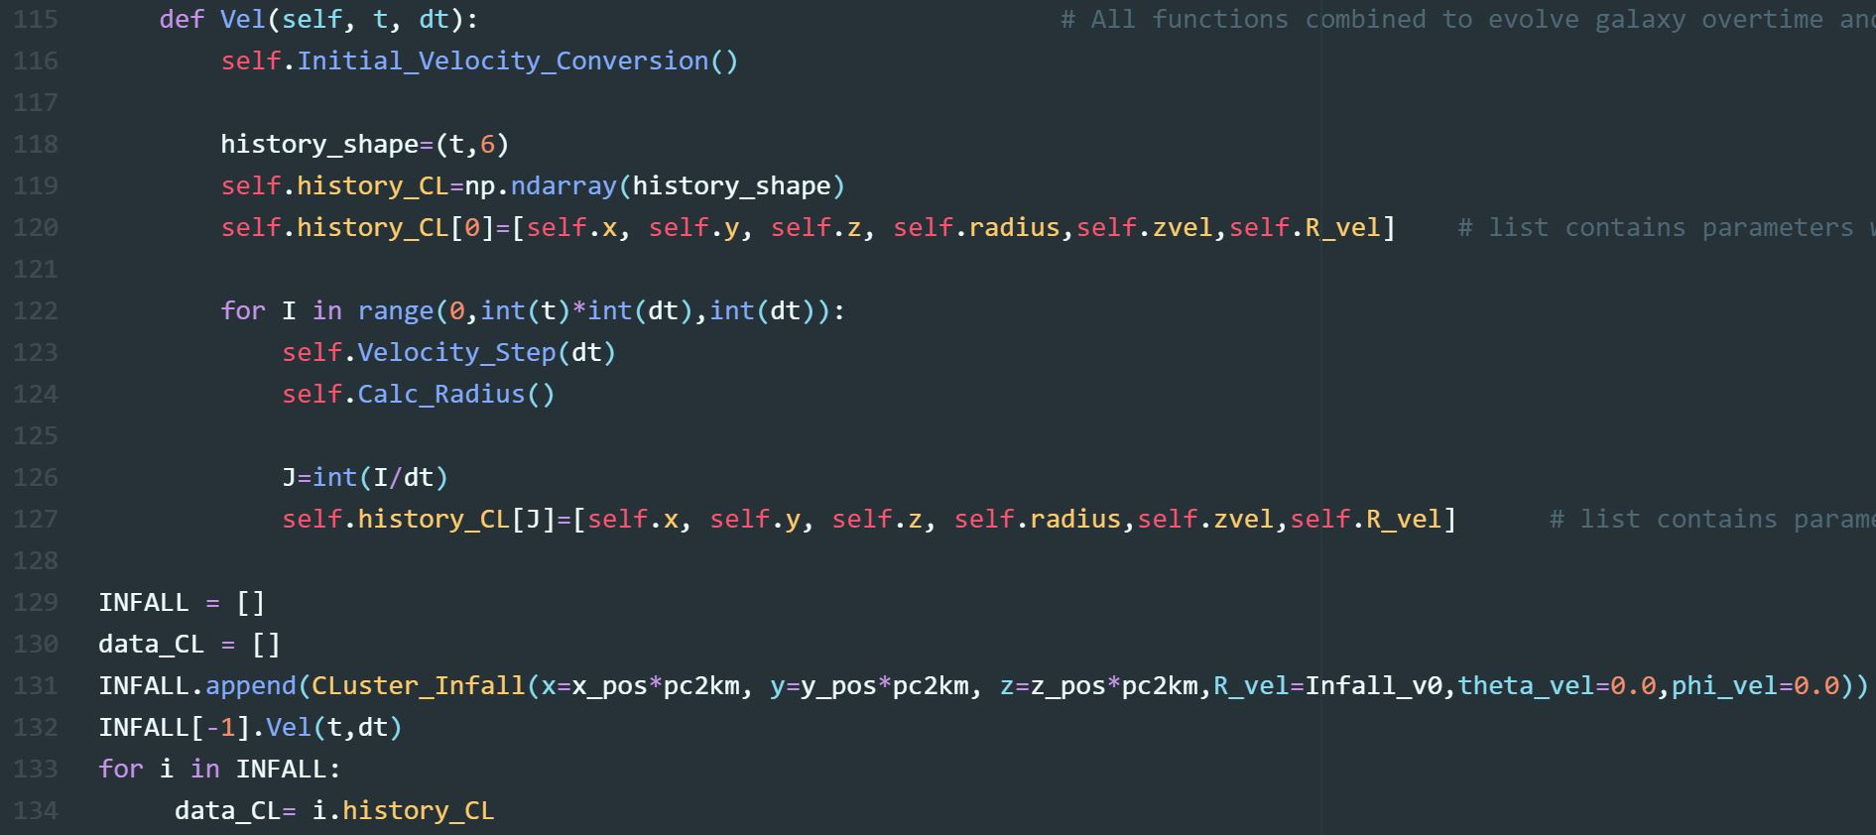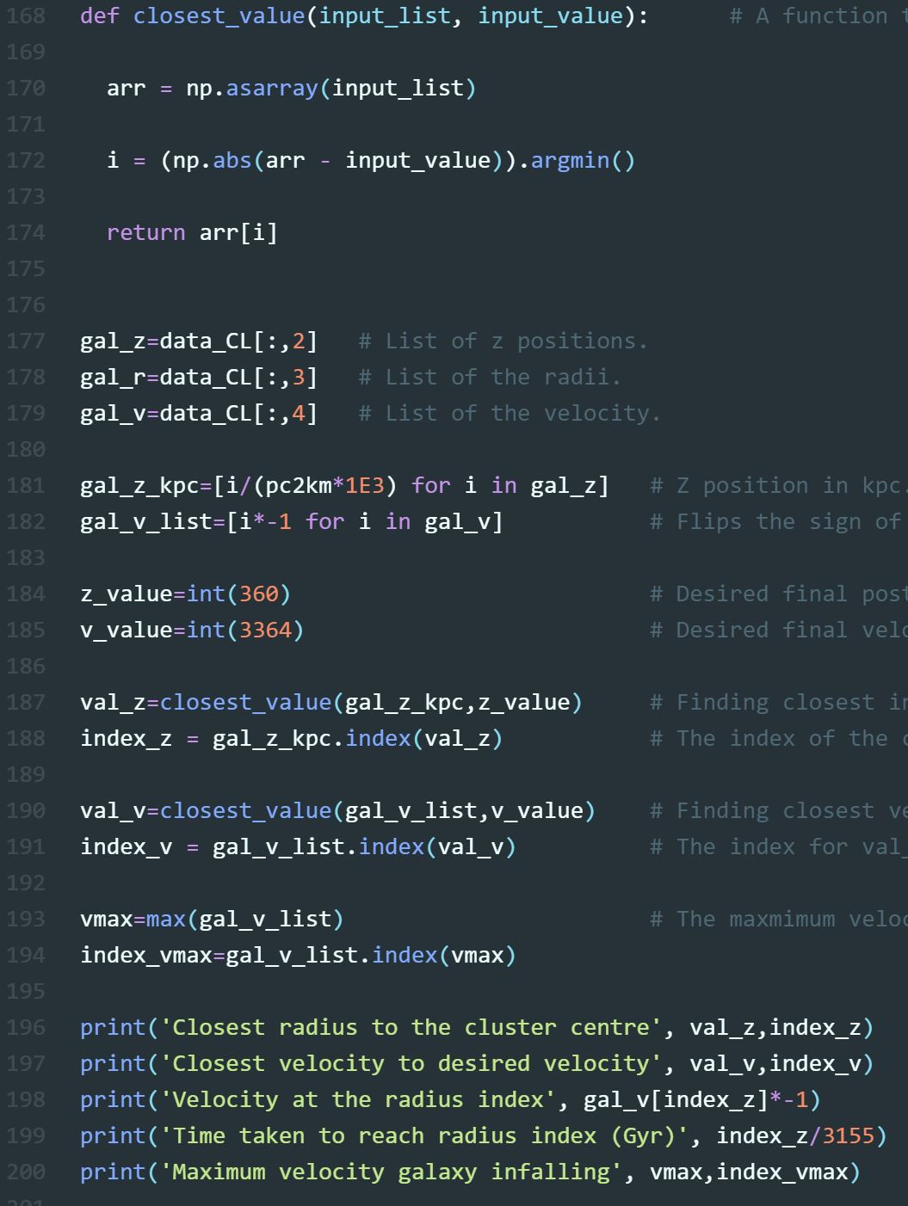

# Analysis

## Stripping Radii

A foundation of RP research is to compare a simulated galaxy’s stripping radius, to that of the G&G Criterion, Eq. (10).

|  |  |  |
| --- | --- | --- |
|  | $$p_{\text{ram }}≥Σ_{g}\frac{dΦ(r,z)}{dz}$$ |  |

Where gas is only stripped if the RP ($p_{\text{ram }}$) is greater than the gravitational restoring force per unit area, $\frac{dΦ(r,z)}{dz}$ at radius, $r$. A flat gas disk is required for the criterion and is represented by a surface density, $Σ_{g}$. The stripping radius is defined where the gravitational restoring force equals the RP. Hence, particles (gas clouds) inside said radius theoretically should not be stripped.

* + 1. Analytic stripping radius

The analytic stripping radius is determined by Stripping_Radius_2. The main inputs/outputs are:

Inputs:

* The Galaxy’s radius (**parsecs**) - maxr
* The distance between radial points i.e., a distance step (**parsecs**) **-** r_step
* The z height above the galaxy (**parsecs**) - z_height
* The surface density conditions from Disk_Setup: the total gas mass (before integration) and scaling radius.
* Parameters for the DM halo, Stellar disk, and Bugle potentials.
* RP conditions for the simulation from Time_Evolution_8_3D.

Outputs:

* For constant RP: A list of the remaining radii when the wind is applied.
* For time varying RP: A list containing stripping radii over the time the wind is applied.

Figure 18 shows the key aspects of the code used to calculate the analytic stripping radius. **Important to note that the arguments for the class** Stripping_Radius() **are in units of parsecs**, line 135. The dimensions were chosen for ease as working in km for maxr, rstep, z_height, is not intuitive. Stripping_Radius() **is the only class where the inputs are in parsecs**. A for loop of points set up in GG_criterion() over the galaxy’s radius range, separated by rstep, see lines 115, 123. The __init__ function defines a variable, z, for the height above the galactic plane in the z axis. Thus, we have the radii (to maxr) and the height above the disk for the gravitational potentials to act. In lines 115,116 and 123,124, Potential_z() is called with a reversed radius order because the outer most regions (where the gas disk is least dense) will be stripped first. The surface density, $Σ_{g}$, for each radial point is calculated along with the 3D radius at the chosen height above the disk. The radius is substituted into the z components of the accelerations (due to the potentials). The contributions of the potentials are then combined and multiplied by $Σ_{g}$ for each particle to form Eq (10)’s right-hand side: defined by the variable pot_pressure, “potential pressure” see, line 96.

In GG_criterion(), lines 108 - 129 the RP (calculated with the same method as Particle) is compared to the potential pressure. For windtype== ‘constant’, lines 113-118, a stripping radius will be immediately determined, as it is a simple comparison between the constant RP value and the potentials at each radius. An analytic approach experiences no ‘reaction time’ to RP unlike a simulation. Lines 117, 118 state that if the RP is smaller than the potential pressure at a given radius append said radius value to the list Stripping. Therefore, we will have a list, in descending order, of all the unstripped radii with the first index being the stripping radius.

For windtype== ‘varying’, like Particle, the RP profile depends on the galaxies infall position and associated velocity (calculated in Infall, see section 5). On line 121 a for loop iterates over the RP duration for the velocity and position indexes. The RP value at each time step is compared to the ‘potential pressure’ with the stripping radii appended to the list stripping_tv.

The duration of the RP is determined by RP_st and RP_fin in units of $dt$. The class is called in lines 135,136 and the data is stored as a pickle file in the same directory, Analysis. For constant RP, uncomment line 141 as the list, R_stripped, only consist of one object. If time varying RP, uncomment line 142 as R_stripped contains the stripping radius at each timestep over the RP duration.

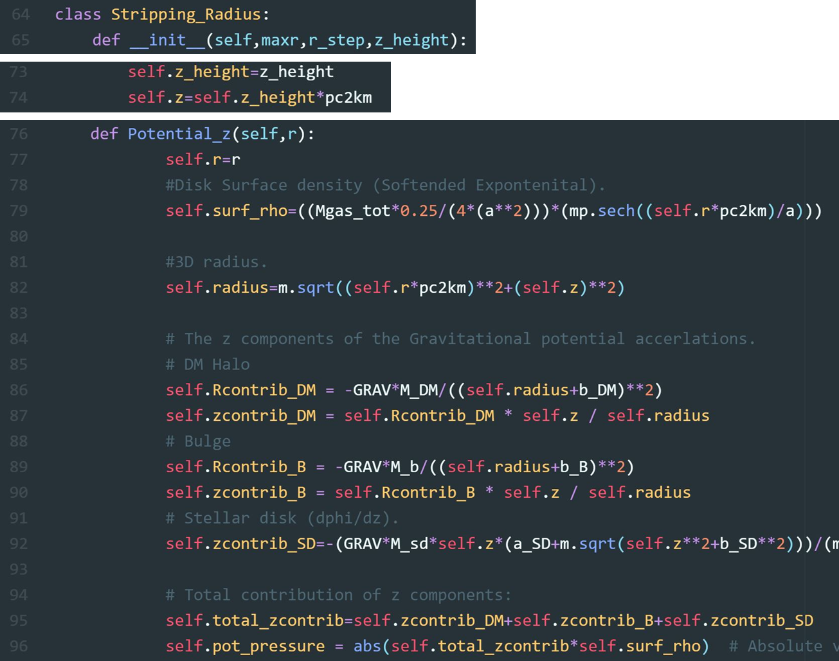

*A part of Figure 18 continued onto the next page.*

* + 1. 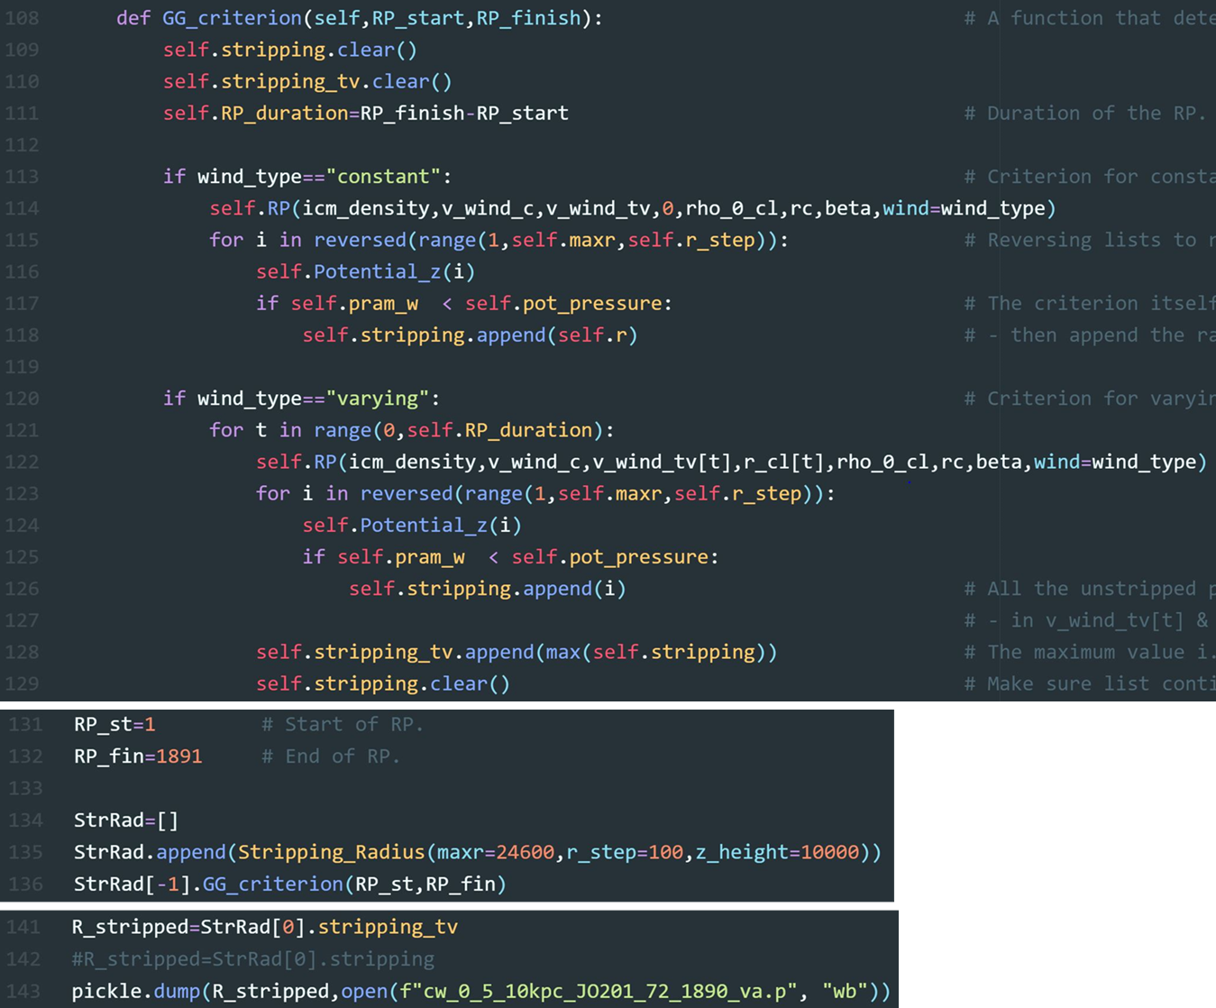Toy Model Stripping Radii

Figure 18: Highlights key aspects of the class Stripping_Radius, which finds a galaxy’s analytic stripping radii based on the Gun & Gott criterion.

The functions Model_Stripping_Radius() and Average() from Analysis are needed to find the TM’s stripping radius. In the constant RP case, the stripped particles are maximally displaced before being partially restored towards the disk. The process is repeated with the particle’s being continually restriped to a sub maximal height until they converge at a given displacement above the disk (where the RP and Gravitational potentials are equal) over 10 Gyr. The process is described in detail in my Master’s project as an ‘oscillation effect’. Figure 19 shows an example of how to analyse the stripping radius from the file main. For illustrative purposes the functions Model_Stripping_Radius() and Average are shown in the code but in general they are called from Analysis. The example follows a galaxy experiencing constant RP initialised at 1 Gyr to 3 Gyr (in terms of t: 3155 to 9465).

1. The data files are opened from their directory.
2. Files are loaded and given variable names RAMs and data. RAMs is the list of Particle class objects and data the 3D array of particle parameters over time: details in sections 3 & 4
3. Model_Stripping_Radius() determines the stripping radius at a given time and height above the disk. The arguments RAMs, time, limit correspond to: the data list, the time the stripping radii is recorded, and the height above the galactic plane to measure the disk’s radius.
4. Model_Stripping_Radius() is called at height of 700pc above the disk for 0-3 Gyr .
5. As a result of the ‘oscillation affect’ under constant RP the stripping radii are averaged over the time of stripping.

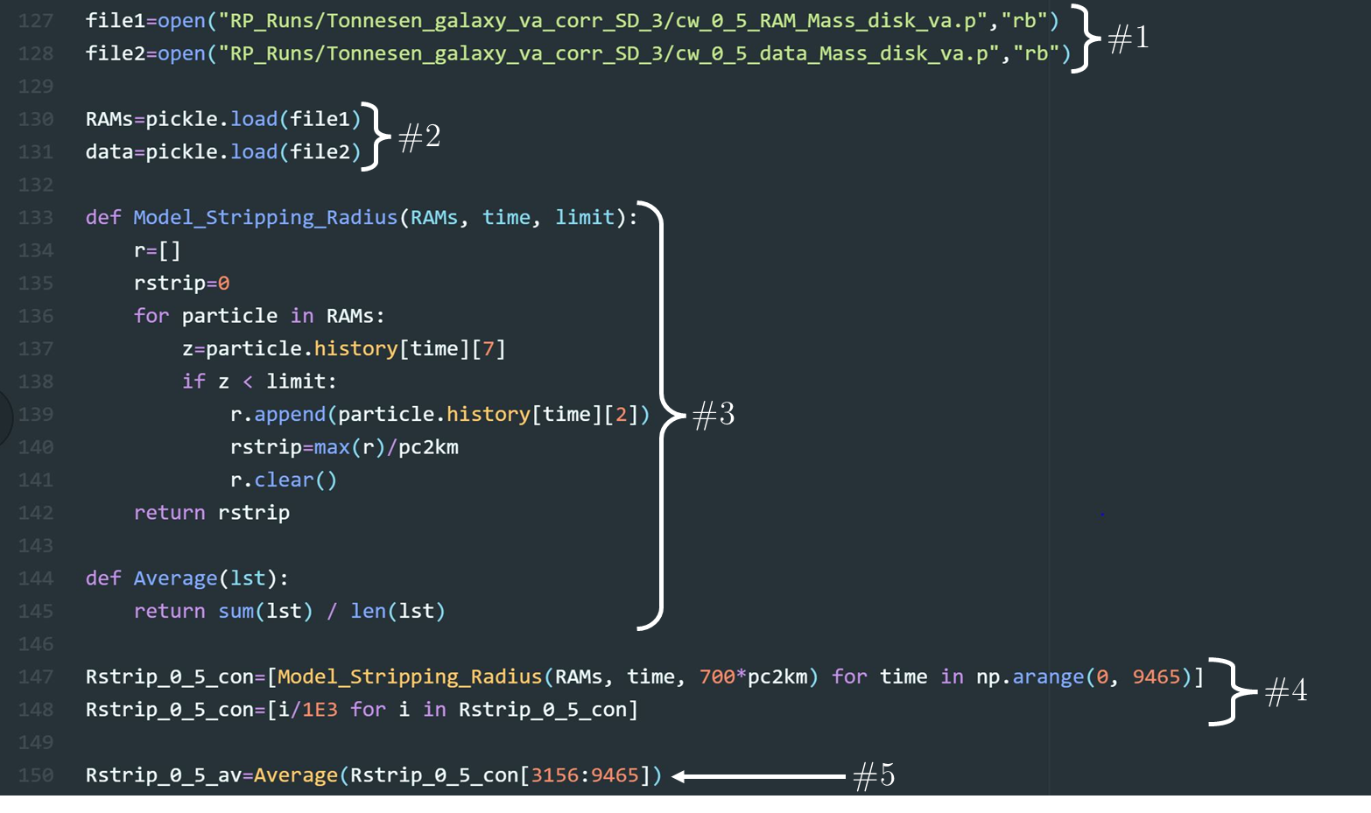

Figure 19: An example of how to analyse the TM’s stripping radius for constant RP. The code is divided into sections denoted by a #.

## Analysis Functions.

Figure 20 shows 3 additional functions in Analysis to Average() and Model_Stripping_Radius(). Though, the functions are commented, a clear picture of their use can be seen with the bottom 3 plots. Each plot generated with the use of a specific function. The upper left plot, created with mass_disk(), shows the cumulative mass within 10 kpc of the galaxy disk; after a time varying RP has been applied. The lower left plot, created with mass_tails(), shows the cumulative mass within the tails, >1kpc from the galaxy. Finally, the upper right plot, created with velocity_distribution(), is a 2D histogram that represents the tail mass distribution as a function of the particles z velocity and displacement.

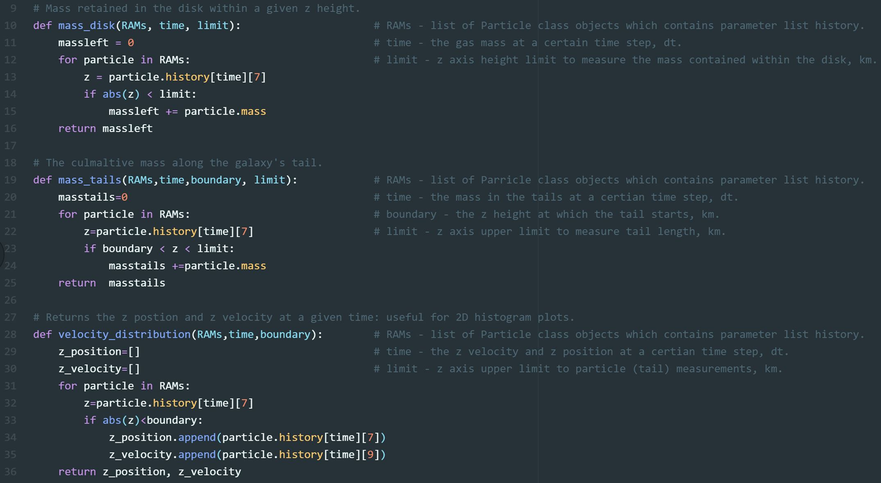

*A part of Figure 20 continued onto the next page.*

# Main

Figure 20: The upper panel shows code from analysis which includes the functions: mass_disk, mass_tails and velocity_distribution. The lower panel shows 3 plots created using said functions. The gas mass within 10 kpc of the disk over time, upper left plot, was generated with extracted data from mass_disk. Lower left plot, the cumulative mass in the tail (> 1kpc) over time: created with use of mass_tails. Upper right plot, the tail mass distribution as a function of the particles z velocity and displacement: created with use of velocity_distribution.

**Overview**: Serves as a hubwhere data from all areas of the TM is collected, opened, and analyzed.

**Tips:** When finished analyzing data instead of deleting code, comment it at the bottom of the file as it is often need more than once. As such, main can be structured in the following manner: first, importing libraries; second, opening data files; third, constants and analysis code; fourth, commented code. One could have commented code organized into sections from gas mass in disk to stripping radii. Therefore, it is easily accessible for reusing on new data or, for example, replotting old data.

## Manipulating Data

Figure 21 shows a simple example for accessing parameters in the array data and list RAMs. Lines 143 -147 shows how to extract properties from RAMs. The first line isolates all the z velocities (history[9]) over all time (i for i in) for the 3rd particle (RAMs[3]). Lines 145 -147 states that for all objects in RAMs (a class object for each particle) append, from history, the radius ([9]) at the time 1.58 Gyr ([5000]). These outcomes are simpler to replicate with the 3D data array, lines 150 and 152, where the desired parameter is the radius (index 2). If we visualize data as a cube, Figure 8, by taking a ‘line’ through the array we can obtain the 3rd particle’s radius over all time (radius_1_particle). Similarly, the process is repeated to find all the particles’ radii at 1.58 Gyr (radius_all_particles). If, for example, we wanted the radii over all time for all 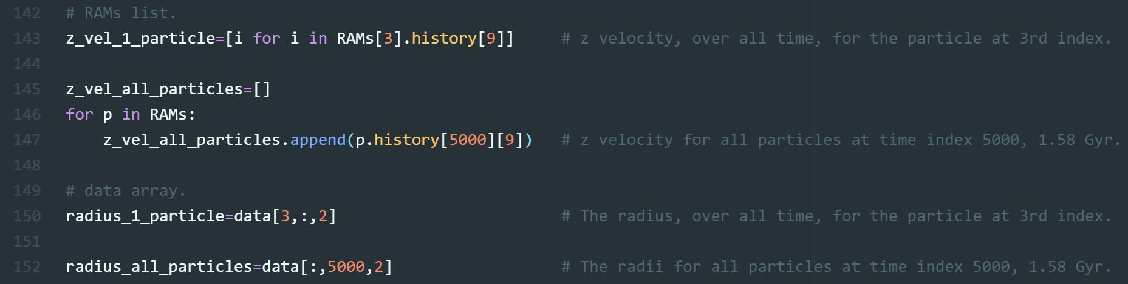particles, we require a slice (a 2d array) through data i.e. data[:, :, 2].

Figure 21:

## Plotting

In the file Graphing, RAMs_Plots contains some useful plotting functions that can be imported to main. These functions serve as a quick check and are not intended as publication quality plots. There are detailed comments in RAMs_Plot on how to use each function. The final lines are commented code for performing an animation of the galaxy in a plane e.g., the x-z plane i.e, a RP stripping video.

# References

Boselli, A., Gavazzi, G., 2006. Publications of the Astronomical Society of the Pacific,118, 842.

Hernquist 1990, The Astrophysical Journal, 356, 359

Hoerner S. F., 1965, Fluid-dynamic Drag: Practical Information on Aerodynamic Drag and Hydrodynamic Resistance. Hoerner Fluid Dynamics

Gunn J. E., Gott J. Richard I., 1972, ApJ, 176, 1

Miyamoto M., Nagai R., 1975, PASJ, 27, 533

Mori M., Burkert A., 2000, The Astrophysical Journal, 538,559

Navarro J. F., Frenk C. S., White S. D. M., 1996, The Astrophysical Journal, 462, 563

Roediger E., Brüggen M., 2006, Monthly Notices of the Royal Astronomical Society, 369, 567

Schindler S., Binggeli B., B ̈ohringer H., 1999, A&A, 343, 420

Vollmer B., Cayatte V., Balkowski C., Duschl W. J., 2001, The Astrophysical Journal, 561

1. * E-mail: dominicktori@gmail.com